Software Requirements Specification
for
MenuWhiz
Prepared by
Zahin Ahmed
Nafisa Tafshir
Md. Jubaer Khan
24.07.2020

Table of Contents
Table of Contents ii
Revision History iii
1. Introduction 1
1.1 Purpose 1
1.2 Document Conventions 1
1.3 Intended Audience and Reading Suggestions 1
1.4 Product Scope 1
2. Overall Description 2
2.1 Product Perspective 2
2.2 Product Functions 3
2.3 User Classes and Characteristics 3
2.4 Operating Environment 3
2.5 Design and Implementation Constraints 3
2.6 User Documentation 4
2.7 Assumptions and Dependencies 4
3. External Interface Requirements 4
3.1 User Interfaces 4
3.1.1 Sample Images of Android Application Interface 4
3.1.2 Sample Images of Website Interface 5
3.2 Hardware Interfaces 7
3.3 Software Interfaces 7
3.4 Communications Interfaces 7
4. System Features 7
4.1 Functional Requirements of Mobile Application 7
4.1.1 Registration 7
4.1.2 Sign in to existing account 8
4.1.3 View menu 9
4.1.4 Order Food 10
4.1.5 Sign out 11
4.2 Functional Requirements of Website Interface 12
4.2.1 Registration 12
4.2.2 Sign in to existing account 13
4.2.3 Add items 13
4.2.4 Update items 14
4.2.5 Accept Order 15
4.2.6 View list of current orders 15
4.2.7 Sign out 16
5. Other Nonfunctional Requirements 17
5.1 Performance Requirements 17
5.1.1 Usage of NFC 17
5.1.2 Configuration of NFC 17
5.1.3 Response time 17
5.2 Safety Requirements 17
5.3 Security Requirements 17
5.4 Software Quality Attributes 18
5.5 Business Rules 18
6. Other Requirements 18
Appendix A: Glossary 18
Appendix B: Analysis Models 19
Appendix C: To Be Determined List 19

Revision History
Name | Date | Reason For Changes | Version
Zahin Ahmed | 28-07-2020 | Updated Chapter 1- Introduction | 1.1
Md. Jubaer Khan | 29-07-2020 | Updated Chapter 2- Overall Description and Chapter 4- System Features | 1.2
Nafisa Tafshir | 31-07-2020 | Updated Chapter 5- Other Nonfunctional Requirements | 1.3
Zahin Ahmed | 31-07-2020 | Updated and completed Chapter 4- System Features | 1.4
Md. Jubaer Khan | 02-08-2020 | Updated Chapter 5-Other Nonfunctional Requirements | 1.5
Nafisa Tafshir | 03-08-2020 | Added ERD diagram | 1.6
Zahin Ahmed | 04-08-2020 | Final edits to Chapter 1, 2, 3, 5. Updated Chapter 6- Other Requirements and Appendices | 1.7
Zahin Ahmed | 05-08-2020 | Updated Chapter 4-System Features, added sample interface pictures to Chapter 3, added Use case diagram | 1.8

Introduction

Purpose
The purpose of this Software Requirements Specification (SRS) is to define and describe the functions and specifications of our project MenuWhiz. This SRS illustrates, in clear terms, the system’s primary uses and required functionality so that the next developers can easily understand what we did and how to change anything if it is required.

Document Conventions
Main Section Titles (Heading 1)
Font: Calibri
Face: Bold
Size: 18

Sub Section Titles (Heading 2)
Font: Calibri
Face: Bold
Size: 14

Heading 3
Font: Calibri
Face: Bold
Size: 13

Heading 4
Font: Calibri
Face: Bold
Size: 12

Paragraph text Explanations
Font: Calibri
Face: Normal
Size: 12

Intended Audience and Reading Suggestions
The SRS is intended for software developers, designers, project managers and testers. The document should be read sequentially as it is, from first page to last page.

Product Scope
MenuWhiz is an online application designed to make dining in restaurants convenient and easy. The users of this application will be of two types: the customers and the restaurants. Customers will be able to use the mobile application whereas Restaurants will use the web interface.

When a customer walks into a restaurant, he will be able to get the menu of that shop in our app just by placing his/her phone in front of an NFC tag. On seeing the menu, the customer will be able to place his order directly through the app. In the current version of our app, we will limit the payment scope to cash only. However, we hope to implement payment by NFC, card or bkash at later stages/versions. We also hope to implement a rating system in the future which will let customers see reviews about the shop’s menu and make an informed decision.

A restaurant will be able to sign up for our platform using the web interface. After registration, he/she take the unique identification number of the NFC tag and add it to his account. He can then update his menu to his account, which he can modify anytime he wishes to depending on available items/stock. This will allow customers to see exactly what is available in the restaurant at a given time, removing the hassle of menu items not being in stock. When an order is placed, the restaurant will have to confirm the order upon payment, after which their stock will be updated.

The goal of this app is to make the dine-in system convenient for customers. It will let customers see the menu of a shop even before taking a seat, which is quite useful considering the number of shops available with various menus. Customers can see instantly see what’s available, which is also quite helpful.

Overall Description

Product Perspective
This product is a new, self-contained product designed to fulfill the current lack of efficient service in the dine-in industry. While apps like Foodpanda make takeout and home delivery simple, websites of individual shops are often unreliable/ outdated, and also difficult to find. For a customer who has just walked in to a restaurant that is new to him/her, finding the currently available list of items digitally is not possible yet. The major components of this product are: an android application (for customers), a website (for restaurants) and a database to contain the customer/restaurant details and menu information. The system will be connected as follows:

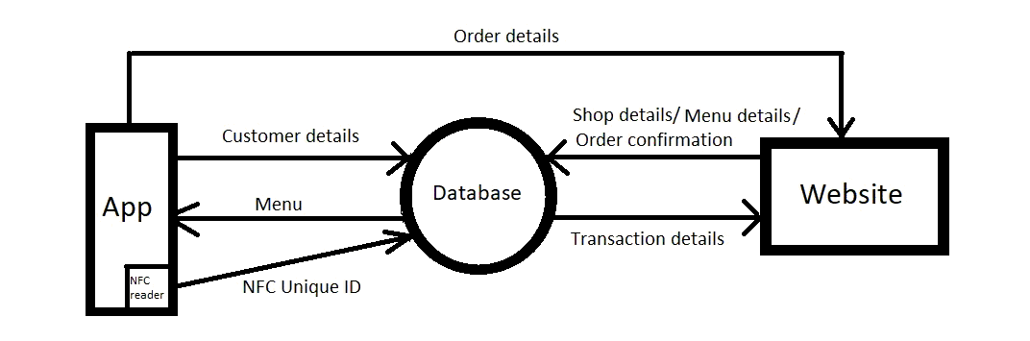
Figure 1 Basic system diagram

Product Functions
Using the mobile application, customers will be able to:

- Register as a customer
- Sign in to existing account
- View menu of the restaurant they entered
- Order food
- Sign out

Using the web interface, Restaurants will be able to:
- Register as a restaurant
- Sign in to existing account
- Add items to their menu
- Update items (quantity/ price)
- Accept order after receiving payment
- View list of current orders
- Sign out

User Classes and Characteristics
There are two main types of users of this software: The restaurant managers and customers of their restaurants. The restaurant managers can use the website interface to manage their restaurant’s menu and sales. The customers can use the mobile application to detect which restaurant they are in, view the menu and place an order.

Both user classes are equally important as without either of them, the platform will not be useful.

Operating Environment
For Android:

Operating System: Android 7.0
Disk Space: 100 MB
RAM: 1 GB
Special feature: NFC enabled phone

For website:
Any GUI system with a browser installed.

Design and Implementation Constraints
Our mobile application and web interface will both require an internet connection to send and retrieve data from the database, hence internet connection is a constraint, without which the product will be unusable.

Both interfaces will be connected to the same database. Therefore, efficient memory usage in the database is important. As the database will not be stored with the product and will be accessed remotely, access to the database will be queued when traffic is high. Hence, too many customers or restaurants signing up simultaneously / multiple customers trying to view menus at the same time might result in longer wait times, hence design or update of the database and access to the database has to be done carefully while taking these factors into consideration.

Android version is a mobile software constraint as the SDK used requires android version 7.0 and above. NFC enabled phones is a hardware requirement for the mobile application, and restaurants will be advised to use NFC tags of type NTAG 21x, as they can be read/write by current NFC enabled smartphones.

User Documentation
Once the development of our product is completed and a stable, working version is ready, a user manual will be provided.

Assumptions and Dependencies
All requirements have been stated previously, no other assumptions are being made.

External Interface Requirements

User Interfaces

Sample Images of Android Application Interface
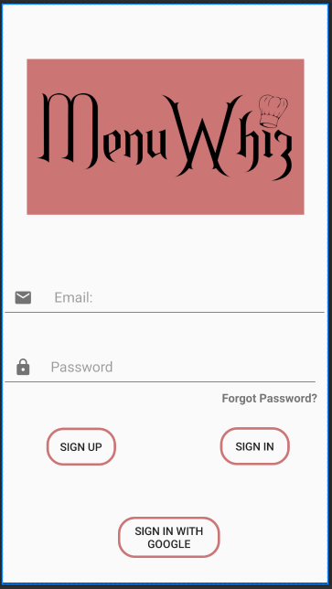

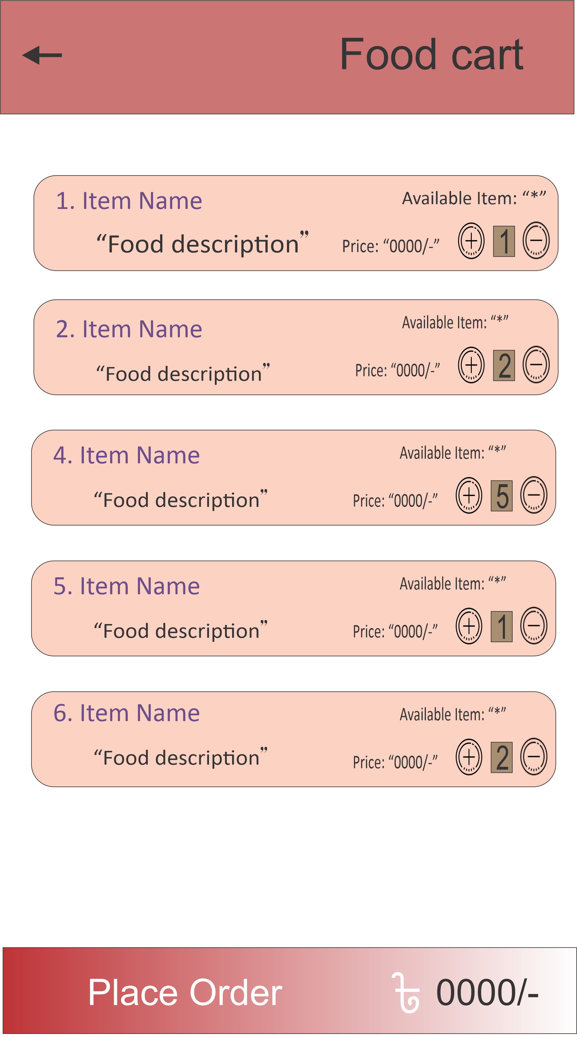

Splash Screen Login Screen Cart

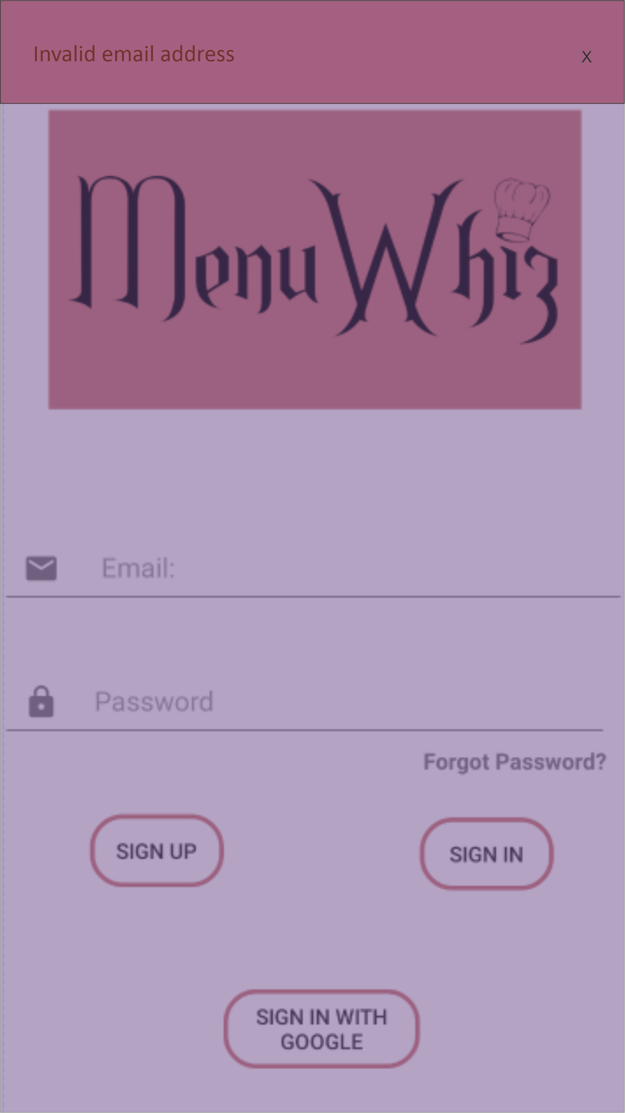

Error Popup

Sample Images of Website Interface

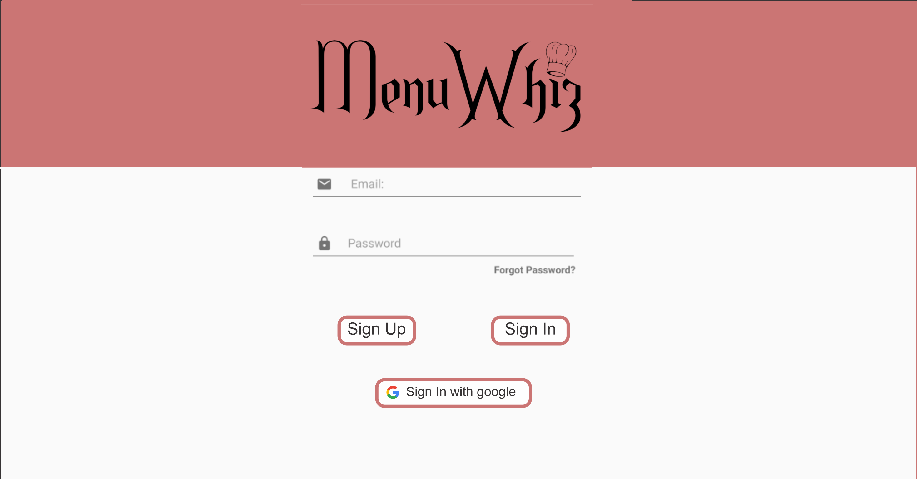

Login Screen

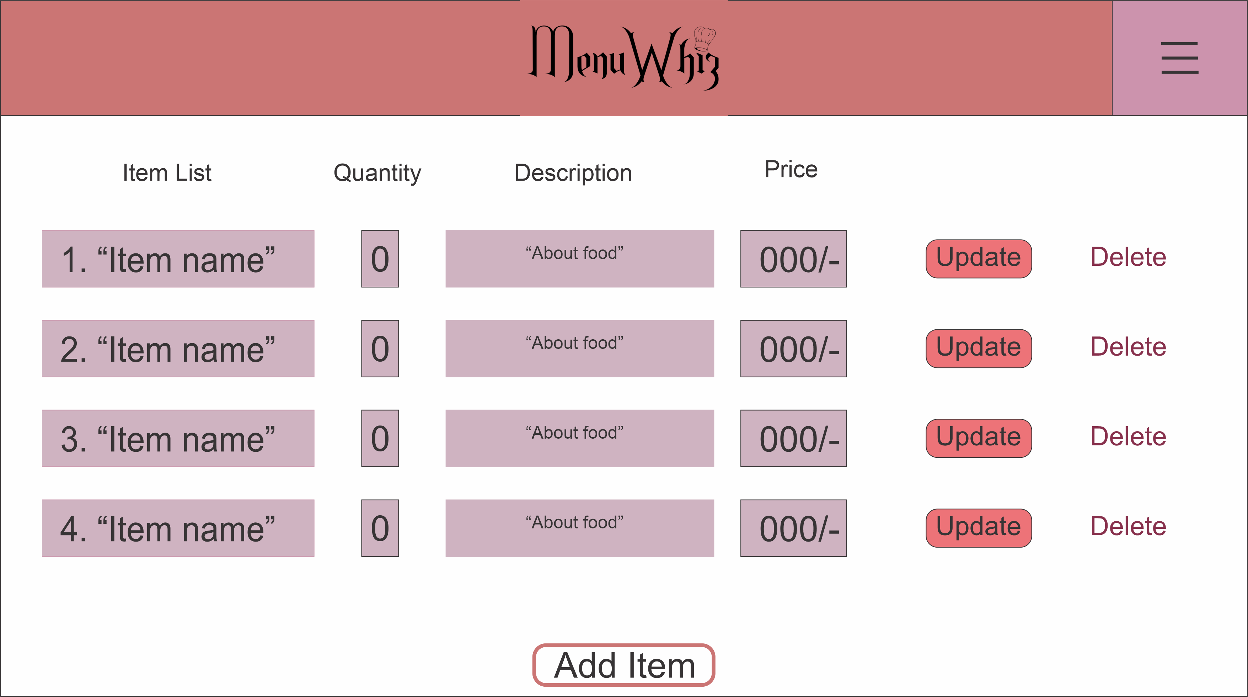
Menu Screen

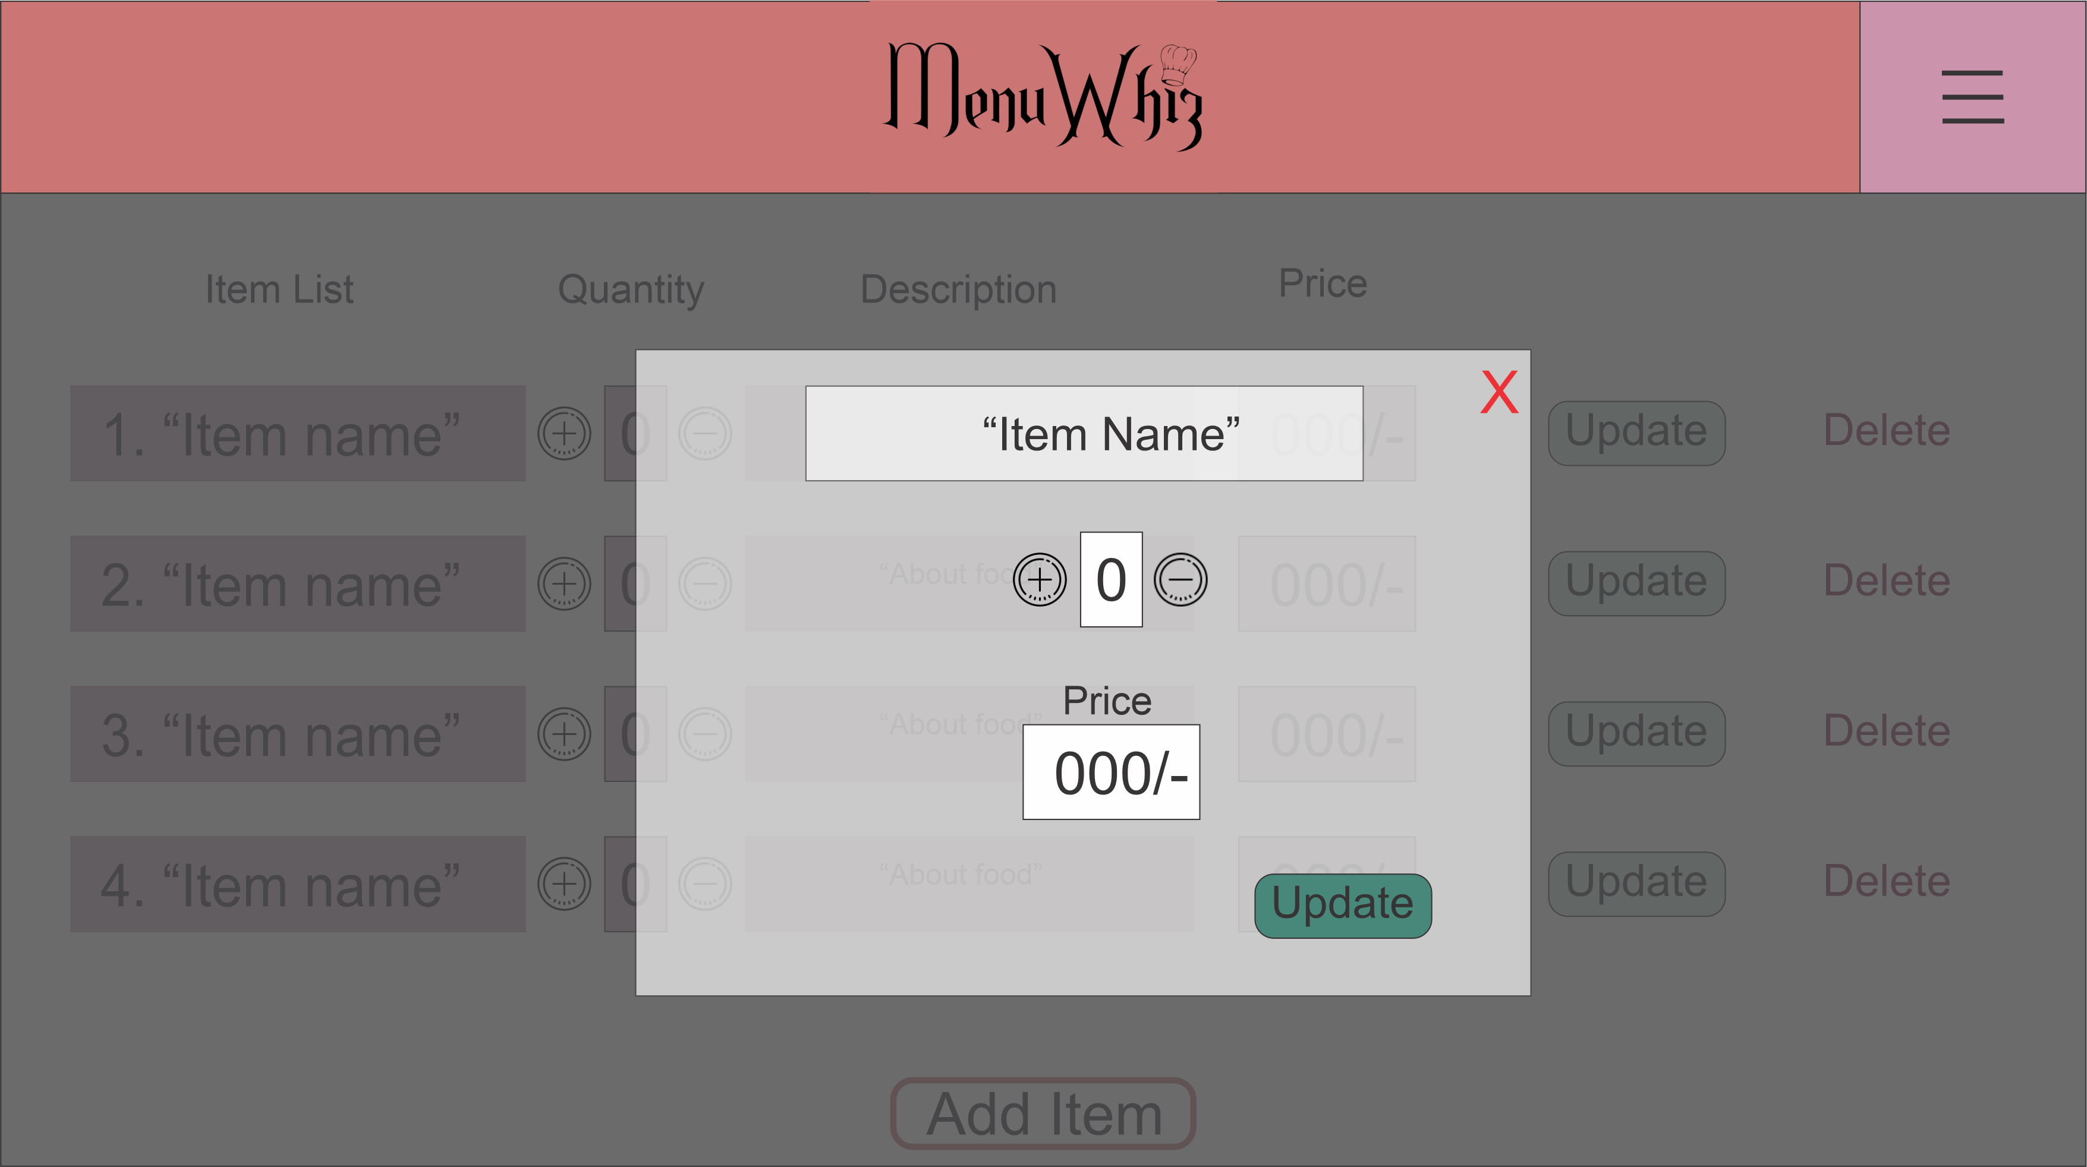
Update Item Popup Screen

Hardware Interfaces
Since our product is based on the usage of NFC tags, phones must be NFC enabled in order to use the application. Website users (restaurant managers) will have to accustom themselves to configuring NFC tags.

Software Interfaces
Both the mobile application and the website will communicate with the database via internet. The operating system will provide such interfaces.

- Database: SQL or SQlite
- Tools: Android Studio (for android development)
- Framework: Django (For backend and website development)
- Languages: Java and Python

Communications Interfaces
- Web browser will be required to access the website.
- Forms will be used for sign in and sign up purposes.
- Network-Server communication will use the HTTP protocol.

System Features

Functional Requirements of Mobile Application
Actors present: Customer, Manager, System.

Registration
UCN: Customer Registration
ACTOR: Customer
UCT: Primary

Description and Priority
Given that the user has downloaded the mobile application, the user is able to register to the platform using information such as email address, password etc. High priority.

Stimulus/Response Sequences
Typical Course of events:
Actor Actions | System Responses
Actor opens application | First screen with logo appears for 2 seconds, then proceeds to Sign up/Sign in screen

Scenario 1: Actor presses “Continue with Google”
Actor Actions | System Responses
Actor presses “Continue with Google” | System responds with “Choose an account” screen
Actor chooses Google account | System responds with interface showing either menu of shop (if placed near a NFC tag) Or screen 2, with the message “Place phone near NFC tag to detect restaurant”

Scenario 2: Actor enters information into form fields
Actor Actions | System Responses
Actor presses “Sign Up” | System responds with screen 1, with form fields asking for name, email address, phone number, password, password verification and “Sign up” button
Actor fills out form and presses “Sign Up” | System responds with interface showing either menu of shop (if placed near a NFC tag) Or screen 2, with the message “Place phone near NFC tag to detect restaurant”

Alternative course of events:
- Error occurred due to internet connectivity or database connection error; will show error popup “Registration Unsuccessful”
- Error occurred due to invalid email address; will show error popup “Invalid email address’
- Error occurred due to password and verification password not matching; will show error pop up “Enter password again”

Functional Requirements
REQ -1: Internet must be available
REQ-2: Database must be connected and online
REQ-3: Not currently signed in to the application

Sign in to existing account
UCN: Customer Sign in
ACTOR: Customer
UCT: Primary
      - Description and Priority
Given that the user has downloaded the mobile application, the user is able to sign in to his old account on the platform using information such as email address and password or Google sign in. High priority.

      - Stimulus/Response Sequences

Typical Course of events:
Actor Actions | System Responses
Actor opens application | First screen with logo appears for 2 seconds, then proceeds to Sign up/Sign in screen

Scenario 2: Actor enters information into form fields

Actor Actions | System Responses
Actor fills in the form and presses “Sign in” | System responds with interface showing either menu of shop (if placed near a NFC tag) Or  screen 2, with the message “Place phone near NFC tag to detect restaurant”

Scenario 1: Actor presses “Continue with Google”
Actor Actions | System Responses
Actor presses “Continue with Google” | System responds with “Choose an account” screen
Actor chooses Google account | System responds with interface showing either menu of shop (if placed near a NFC tag) Or screen 2, with the message “Place phone near NFC tag to detect restaurant”
Alternative course of events:
- Error occurred due to internet connectivity or database connection error; will show error popup “Sign in Unsuccessful”
- Error occurred due to invalid email address and password combination; will show error popup “Invalid email or password”
      - Functional Requirements
REQ -1: Internet must be available
REQ-2: Database must be connected and online
REQ-3: Not currently signed in to the application

View menu
UCN: View menu as customer
ACTOR: Customer
UCT: Primary
      - Description and Priority
After signing in or signing up, the user is able to view the menu of the restaurant by placing his phone near the NFC tag of the restaurant. High priority.

      - Stimulus/Response Sequences

Typical Course of events:
Actor Actions | System Responses
Actor opens application | First screen with logo appears for 2 seconds

Scenario 1: Actor has placed his/her phone near the NFC tag
Actor Actions | System Responses
Actor places his phone near NFC tag | System responds with interface showing menu of the shop

Scenario 2: Actor has not placed his/her phone near the NFC tag
Actor Actions | System Responses
Actor has not placed his/her phone near the NFC tag | System responds with interface showing screen 2, with the message “Place phone near NFC tag to detect restaurant”
Actor places his phone near NFC tag | System responds with interface showing menu of the shop

Alternative course of events:
- Error occurred due to internet connectivity or database connection error; will show error popup “Cannot connect to database right now”
      - Functional Requirements
REQ -1: Internet must be available
REQ-2: Database must be connected and online
REQ-3: NFC tag of shop has to be properly configured
REQ-4: Actor is signed into the application prior

Order Food
UCN: Order Food
ACTOR: Customer
UCT: Primary
      - Description and Priority
After viewing the menu, order food from the available items and see whether his order has been approved or not. High priority.

      - Stimulus/Response Sequences
Typical Course of events:
Actor Actions | System Responses
Actor opens application | First screen with logo appears for 2 seconds

Scenario 1: Actor has placed his/her phone near the NFC tag
Actor Actions | System Responses
Actor places his phone near NFC tag | System responds with interface showing menu of the shop
Actor adds items from the menu using the “+” button beside items | System responds by adding those items to his order list
Actor presses “Place order” | System responds by conveying the order to the restaurant website for approval

Scenario 2: Actor has not placed his/her phone near the NFC tag
Actor Actions | System Responses
Actor has not placed his/her phone near the NFC tag | System responds with interface showing screen 2, with the message “Place phone near NFC tag to detect restaurant”
Actor places his phone near NFC tag | System responds with interface showing menu of the shop
Actor adds items from the menu using the “+” button beside items | System responds by adding those items to his order list
Actor presses “Place order” | System responds by conveying the order to the restaurant website for approval
Alternative course of events:
- Error occurred due to internet connectivity or database connection error; will show error popup “Cannot connect to database right now”
- Error occurred due to item going out of stock at that moment; will show error popup “Item unavailable”
      - Functional Requirements
REQ -1: Internet must be available
REQ-2: Database must be connected and online
REQ-3: NFC tag of shop has to be properly configured
REQ-4: Actor is signed into the application prior

Sign out
UCN: Sign out of account
ACTOR: Customer
UCT: Primary
      - Description and Priority
To change users or to not stay logged in, the user can sign out of the app. High priority.

      - Stimulus/Response Sequences

Typical Course of events:
Actor Actions | System Responses
Actor opens application | First screen with logo appears for 2 seconds followed by interface showing either menu of shop (if placed near a NFC tag) Or screen 2, with the message “Place phone near NFC tag to detect restaurant”
Actor presses “Sign out” button on navigation bar | System responds by going back to Sign up/Sign in screen

      - Functional Requirements
REQ-1: Actor is signed into the application prior

Functional Requirements of Website Interface

Registration
UCN: Restaurant Registration
ACTOR: Manager
UCT: Primary

Description and Priority
Given that the user has accessed the website, the user is able to register to the platform using information such as email address, password etc. High priority.

Typical Course of events:
Actor Actions | System Responses
Actor visits “www.menuwhiz.com” | System responds with Sign up/Sign in screen
Actor presses on “Sign up” | System responds with screen 1, with form fields asking for name, email address, phone number, password, password verification and “Sign up” button, along with option for “Continue with Google“

Scenario 1: Actor presses “Continue with Google”
Actor Actions | System Responses
Actor presses “Continue with Google” | System responds with “Choose an account” screen
Actor chooses Google account | System responds with interface to configure NFC Tag
Actor presses “Add NFC tag” | System saves NFC tag unique ID to database and responds with interface to update menu

Scenario 2: Actor enters information into form fields
Actor Actions | System Responses
Actor presses “Sign up” | System responds with interface to configure NFC Tag
Actor presses “Add NFC tag” | System saves NFC tag unique ID to database and responds with interface to update menu
Alternative course of events:
- Error occurred due to internet connectivity or database connection error; will show error popup “Registration Unsuccessful”
- Error occurred due to invalid email address; will show error popup “Invalid email address’
- Error occurred due to password and verification password not matching; will show error pop up “Enter password again”
- Error occurred due to invalid NFC tag; will show error popup “Invalid NFC ID”

Functional Requirements
REQ -1: Internet must be available
REQ-2: Database must be connected and online
REQ-3: Not currently signed in to the website

Sign in to existing account
UCN: Restaurant Sign in
ACTOR: Manager
UCT: Primary
      - Description and Priority
Given that the user has accessed the website, the user is able to sign in to his old account on the platform using information such as email address and password or Google sign in. High priority.

      - Stimulus/Response Sequences

Typical Course of events :
Actor Actions | System Responses
Actor visits “www.menuwhiz.com” | System responds with Sign up/Sign in screen

Scenario 1: Actor enters information into form fields
Actor Actions | System Responses
Actor fills in the form and presses “Sign in” | System responds with interface showing existing menu and option to add items

Scenario 2: Actor presses “Continue with Google”
Actor Actions | System Responses
Actor presses “Continue with Google” | System responds with “Choose an account” screen
Actor chooses Google account | System responds with interface showing existing menu and option to add items

Alternative course of events:
- Error occurred due to internet connectivity or database connection error; will show error popup “Sign in Unsuccessful”
- Error occurred due to invalid email address and password combination; will show error popup “Invalid email or password”
      - Functional Requirements
REQ -1: Internet must be available
REQ-2: Database must be connected and online
REQ-3: Not currently signed in to the website

Add items
UCN: Add items to menu
ACTOR: Manager
UCT: Primary
      - Description and Priority
Given that the user has signed in to the website, the user is able to add a new item to his/her menu. High priority.

      - Stimulus/Response Sequences

Typical Course of events:
Actor Actions | System Responses
Actor visits www.menuwhiz.com and signs in | System responds with interface showing existing menu and option to add items
Actor presses on “Add item” | System responds with screen 4, with form fields asking for name, price and quantity of new item and “Add item” button“
Actor fills in the form fields and presses “Add items” | System adds the item to the database and responds by going back to previous screen
Alternative course of events:
- Error occurred due to internet connectivity or database connection error; will show error popup “Item addition Unsuccessful”
      - Functional Requirements
REQ -1: Internet must be available
REQ-2: Database must be connected and online
REQ-3: Signed in to the website beforehand

Update items
UCN: Update or delete items of existing menu
ACTOR: Manager
UCT: Primary
      - Description and Priority
Given that the user has signed in to the website, the user is able to update an existing item on his/her menu. High priority.

      - Stimulus/Response Sequences

Typical Course of events:
Actor Actions | System Responses
Actor visits www.menuwhiz.com and signs in | System responds with interface showing existing menu and option to add items

Scenario 1: Actor presses on “Update” beside the item he wants to update

Actor Actions | System Responses
Actor presses on “Update” icon beside the item he wants to update | System responds with popup, with form fields asking for new price and quantity of new item and “Update” button“
Actor fills in the form fields and presses “Update” | System adds the item to the database and responds by going back to previous screen

Scenario 1: Actor presses on “Delete” beside the item he wants to update

Actor Actions | System Responses
Actor presses on “Delete” icon beside the item he wants to delete | System responds by asking for confirmation via popup
Actor presses “confirm” | System responds by deleting the item and refreshing the menu

Alternative course of events:
- Error occurred due to internet connectivity or database connection error; will show error popup “Item update Unsuccessful”
      - Functional Requirements
REQ -1: Internet must be available
REQ-2: Database must be connected and online
REQ-3: Signed in to the website beforehand

Accept Order
UCN: Accept incoming order
ACTOR: Manager
UCT: Primary
      - Description and Priority
Given that the user has signed in to the website, the user is able to add receive an order when it is placed and approve it upon payment. High priority.

      - Stimulus/Response Sequences

Typical Course of events:
Actor Actions | System Responses
Actor visits www.menuwhiz.com and signs in | System responds with interface showing existing menu and option to add items
Actor receives popup showing new order | System waits for response
Actor presses “accept order” upon payment completion | System adds the order to the current orders list and returns to the previous screen

Alternative course of events:
- Error occurred due to internet connectivity or database connection error; will show error popup “Order could not be confirmed”
- If payment not completed within 5 minutes, the popup closes by itself.
      - Functional Requirements
REQ -1: Internet must be available
REQ-2: Database must be connected and online
REQ-3: Signed in to the website beforehand

View list of current orders
UCN: View list of current order
ACTOR: Manager
UCT: Primary
      - Description and Priority
Given that the user has signed in to the website, the user is able to view the current list of orders.

      - Stimulus/Response Sequences

Typical Course of events:
Actor Actions | System Responses
Actor visits www.menuwhiz.com and signs in | System responds with interface showing existing menu and option to add items
Actor clicks on “View current list of orders” | System responds by showing screen containing details of current orders.

Alternative course of events:
- Error occurred due to internet connectivity or database connection error; will show error popup “Cannot be loaded right now”
      - Functional Requirements
REQ -1: Internet must be available
REQ-2: Database must be connected and online
REQ-3: Signed in to the website beforehand

Sign out
UCN: Sign out of account
ACTOR: Restaurant
UCT: Primary
      - Description and Priority
To change users or to not stay logged in, the user can sign out of the website. High priority.
      - Stimulus/Response Sequences

Typical Course of events:
Actor Actions | System Responses
Actor visits www.menuwhiz.com and signs in | System responds with interface showing existing menu and option to add items
Actor presses “Sign out” button on navigation bar | System responds by going back to Sign up/Sign in screen

      - Functional Requirements
REQ-1: Actor is signed into the application prior

Other Nonfunctional Requirements

Performance Requirements

Usage of NFC
TITLE: Usage of the NFC feature
PURPOSE: By tapping their phone against a menu, sign or poster embedded with a NFC tag, customers will receive the menu
OVERVIEW: Customers should be able to detect the NFC within 1 second. Specific placement of phone should not be required as long as phone is within 20cm of the NFC tag.

Configuration of NFC
TITLE: Configuration of NFC
PURPOSE: After registration, restaurants should be able to configure their own NFC tags simply by following the instructions given on the website.
OVERVIEW: Instructions should not be on more than two pages. Should be thorough, understandable and concise. Should be easy to follow through.

Response time
TITLE: Response time
PURPOSE: To measure the time needed to do basic operations such as accessing the database, clicking forms etc.
OVERVIEW:
- Accessing the database should not take more than 2 seconds if internet connection is stable.
- Clicking on form fields should require no more than 1 click.
- Generation of popup messages should not take more than 2 seconds

Safety Requirements
- Information transmission to server has to be secure.
- Only the customers will have access to their personal details and only restaurants will have access to their menus and NFC tags.
- NFC tags cannot be edited once written by restaurant. Has to stay locked.
- When an order is placed, only the two parties of the specific order in question should have access to the information.
- Database will store all information securely, without causing any unwanted change.

Security Requirements
- Data will be kept secure using regular backups, and the backups will be stored in secure locations. We will maintain a backup on cloud storage as well with proper security measures.
- No third party will gain access to the personal information of users.
- Communication to and from the server will be encrypted to ensure it cannot be misused even if someone intercepts the data.
- More than 10 log in attempts will result in the account getting locked down for a period of time.

Software Quality Attributes
Reliability:
- Both the application and the website can be used by many users frequently.

Robustness:
- Frequent errors can be handled easily.
- There is no scope of full system failure for any kind of error.

Maintainability:
- Source code and quality of documentation must be specific and clear.
- The system shall provide the capability to back-up data

Portability:
- User can use this application anytime, anywhere and from any android device.

Business Rules
- Restaurants cannot conduct any illegal business through their shop, otherwise their accounts will be blocked and barred from re-registering.
- If there are multiple branches of one restaurant, each needs a separate account, NFC Tag and menu.
- Actions such as misbehaving with the customers and any harmful actions towards customers will result in the restaurant being banned from the platform.
- Restaurants are required to ensure the safety of their customers at all times, hence decisions such as location selection and staff selection should be taken seriously.

Other Requirements
Depending on the development and growth of this project, it might be necessary to shift to a more robust database management system eventually.
Reuse or extension of the product will require permission of the original developers of the product.

Appendix A: Glossary
Term | Definition
MenuWhiz | Name of product described in this SRS
Customer | Someone who interacts with the mobile phone application
Restaurant | Someone who interacts with the website interface
UCN | Use Case Name
ACTOR | User who will use the feature
UCT | Use Case Type
REQ-x | Requirements

Appendix B: Analysis Models
Use Case Diagram:
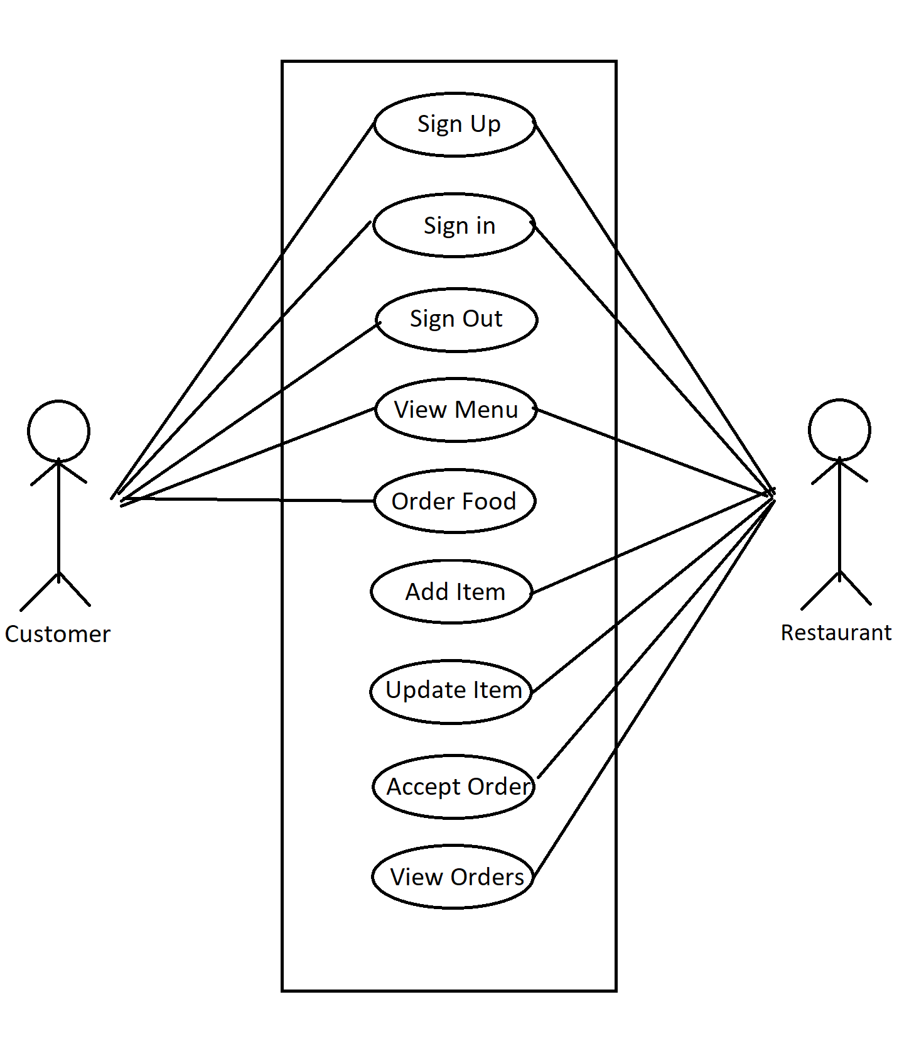

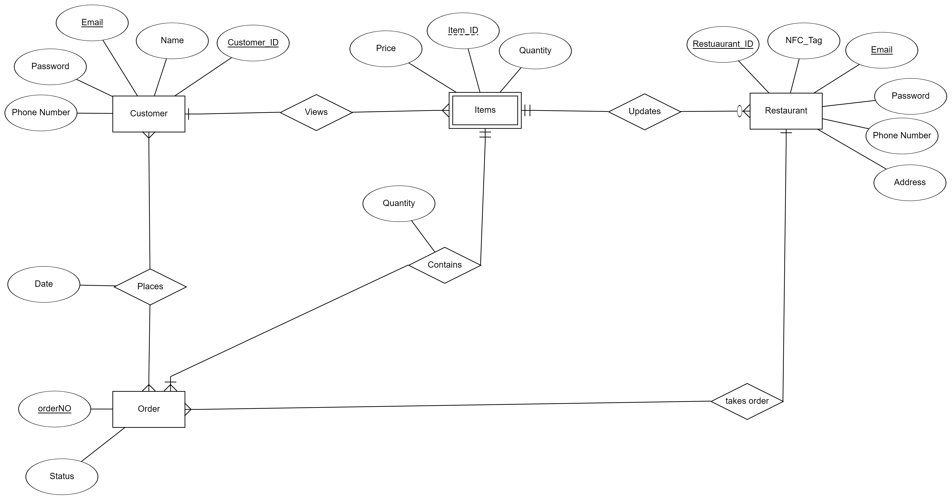
Entity-Relationship Diagram:

Appendix C: To Be Determined List
- A suitable library/ API is needed to allow NFC writing/reading to be done by the website/application respectively

